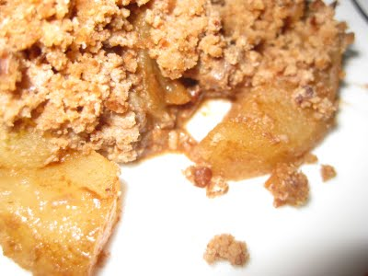

Apple Crisp

INGREDIENTS:
4 medium Granny Smith or Golden Delicious apples peeled, cored, and sliced 1/4 inch thick
2 tablespoons granulated sugar
½ teaspoon ground cinnamon
¼ teaspoon ground nutmeg
¼ cup packed light brown sugar
¼ cup uncooked rolled oats
5 Tablespoons whole-wheat flour
2 tablespoons cold unsalted butter, cut into small pieces

INSTRUCTIONS:
- Pre-heat the oven to 375°F and arrange a rack in the middle.
- Lightly coat an 8-by-8-inch baking dish with cooking spray.
- Combine the apples, granulated sugar, cinnamon, and nutmeg in a large bowl and toss to coat. Place the apple mixture in the prepared baking dish and set aside.
- Using the same bowl as for mixing the apples, mix together the brown sugar, oats and flour. With your fingertips, blend in the butter pieces until small clumps form and the butter is well incorporated, about 2 minutes.
- Sprinkle the topping evenly over the apples and bake until the streusel is crispy and the apples are tender, about 30 - 35 minutes, or until the apples are tender and the top is golden brown.

