Name _______________________________________________ Date _____________ Period _____ Culinary Arts
Ch 15 Vegetables p. 268 – 278 (26 pts)

1. How many cups of veggies, per day, does MyPlate suggest teens eat? _________ - _________

2. What are the nutritional benefits of vegetables? (4 pts)

____________________________________________________ ____________________________________________________

____________________________________________________ ____________________________________________________

3. What are the five subgroups in which vegetables are sorted? Give 3 examples of each. (5pts)

Dark Green : _________________________, _________________________, ___________________________

_________________________: _____carrots , _________________________, ___________________________

_________________________: _________________________, peas , ___________________________

_________________________: _________________________, __________________________, green peas_________

Other : _________________________, __________________________, __________________________

4. What changes take place as vegetables are cooked? (4 pts)

________________________________________________ ________________________________________________

________________________________________________ ________________________________________________

5. How should vegetable be cooked to maintain optimum quality? ____________________________

6. What is responsible for the color of vegetables? (4 pts)

Green: ________________________________ Orange: ________________________________

White: _________________________________ Red: _________________________________

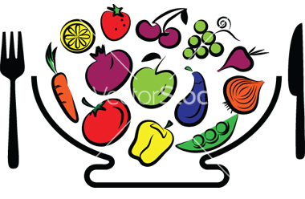
7. What are 7 methods for cooking vegetables?

________________________, ________________________,

________________________, ________________________,

________________________, ________________________,

________________________ (7 pts)
Ch 15 Vegetables

1. How many cups per day does MyPlate suggest teens eat?

2 ½ - 4 cups

2. What are the nutritional benefits of vegetables?

Low in Fat
Low in Calories
Rich in Fiber
Good sources of Vitamins: A, C, & E also Folate and Potassium

3. What are the five subgroups in which vegetables are sorted? Give 3 examples of each.

Dark Green Vegetables
broccoli, spinach, collards, kale,
Orange Vegetables
carrots, pumpkin, sweet potatoes, all types of squash
Legumes
kidney beans, peas, lentils, soybeans,
Starchy Vegetables
corn, white potatoes, lima beans, green peas,
Other Vegetables (Fruit)
tomato, brussel sprouts, bell peppers, beets, cabbage, celery, cucumbers, green beans, onions,

4. What changes take place as vegetables are cooked?

Cellulose (fiber) softens to make chewing easier.
Starch absorbs water, swells and becomes easier to digest.
Flavor and color changes.
Nutrients dissolve.

5. How should vegetable be cooked to maintain optimum quality?

Crisp-tender

6. What is responsible for the color of vegetables?

Green: Chlorophyll
Orange: Carotene
White: Flavones
Red: Anthocyanin

7. What are 7 methods for cooking vegetables?

boiling, steaming, pressure-cooking,
baking, frying, broiling, microwaving

