Name _______________________________________________ Date _____________ Period _____ Culinary Arts
Ch 15 Vegetables p. 268 – 278 (26 pts)

1. How many cups of veggies, per day, does MyPlate suggest teens eat? _________ - _________

2. What are the nutritional benefits of vegetables? (4 pts)

____________________________________________________ ____________________________________________________

____________________________________________________ ____________________________________________________

3. What are the five subgroups in which vegetables are sorted? Give 3 examples of each. (5pts)

Dark Green : _________________________, _________________________, ___________________________

_________________________: _____carrots , _________________________, ___________________________

_________________________: _________________________, peas , ___________________________

_________________________: _________________________, __________________________, green peas_________

Other : _________________________, __________________________, __________________________

4. What changes take place as vegetables are cooked? (4 pts)

________________________________________________ ________________________________________________

________________________________________________ ________________________________________________

5. How should vegetable be cooked to maintain optimum quality? ____________________________

6. What is responsible for the color of vegetables? (4 pts)

Green: ________________________________ Orange: ________________________________

White: _________________________________ Red: _________________________________

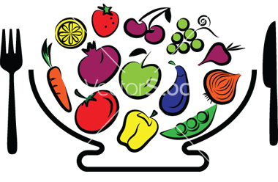
7. What are 7 methods for cooking vegetables?

________________________, ________________________,

________________________, ________________________,

________________________, ________________________,

________________________ (7 pts)

