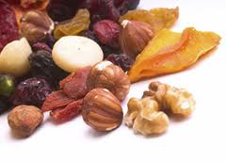6
Healthy Granola Energy Bars
Yield: 10 Source: Mrs. Robinson

Dry Ingredients: Moist Ingredients:
2 c. old fashioned oats ¼ c. honey
¼ c. semi-sweet chocolate chips ½ c. peanut butter
¼ c. sweetened coconut shavings 1 t. vanilla
2 T. dried sweetened cranberries
1 t. cinnamon
½ t. nutmeg
¼ t. salt

Preparation:
- Measure and combine all dry ingredients in a medium bowl.
- Measure and combine all moist ingredients in a large bowl.
- Add dry ingredients to moist ingredients. Mix thoroughly till dry ingredients are moistened.
- Cut 8 – 10 squares of foil, 6” x 6”.
- Spoon granola into the center of each piece of foil.
- Carefully wrap foil around granola into a small square.
- Put wrapped granola into a labeled plastic bag and refrigerate over night.

Nutrition:
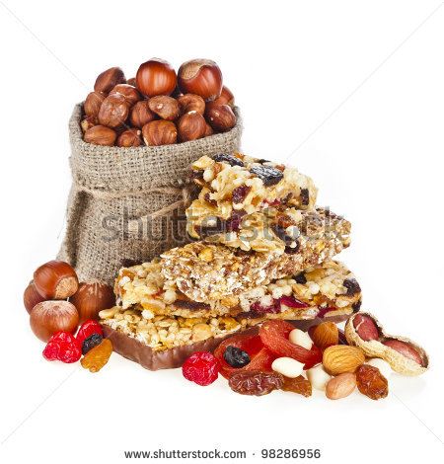
Calories 205.4
Total Fat 9.9g
Sat. Fat 2.6g
Poly Fat .4g
Mono .4g
Cholesterol 0
Sodium 119.4
Potassium 13 mg
Total Carbohydrate 26.9g
Dietary Fiber 2.7g
Sugars 12.8g
Protein 4.9g
Vitamin E 4.1%
Iron 6.5%
Niacin 8.2 %

