Hearty Healthy Tasty Quinoa
1 tablespoon vegetable oil
1/4 onion, diced finely
1 clove of garlic (peeled and minced)
1 1/2 bell pepper, diced (1/2 green, 1/2 yellow, 1/2 red)
1/2 cup of uncooked quinoa
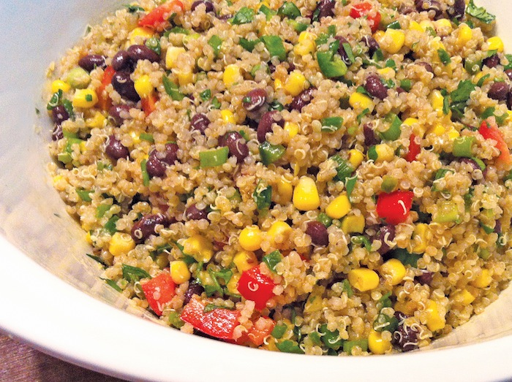
1 cup broth (1 t chicken bouillon & 1 cup water)

1/2 teaspoon ground cumin
1/4 teaspoon cayenne pepper
1/2 teaspoon lemon juice
1/4 teaspoon garlic powder
salt and pepper to taste
1/3 cup of frozen corn kernels
1/2 a cup of black beans, rinsed and drained
Shredded parmesan cheese for topping

Directions:
Heat the oil in a medium sauce pan over medium heat. Stir in the onion and garlic, and sauté. After 2-3 minutes, add bell pepper. Sauté until lightly browned.
While onion, garlic and bell pepper are cooking, rinse and drain your quinoa. Use caution as most strainers are too large and the quinoa will slip through.
After onion is slightly brown, add rinsed quinoa and cover with broth. Season with cumin, cayenne pepper, lemon juice, garlic salt, salt and pepper. Bring the mixture to a boil. After it is boiling, cover, reduce heat to low and let simmer for 20 minutes. When the 20 minutes is up, add frozen corn.
Simmer for 5 minutes. Next, mix in beans and heat through. Portion into bowls and top with cheese.

