Master Smoothie Recipe
The Oregonian, 2-28-2012
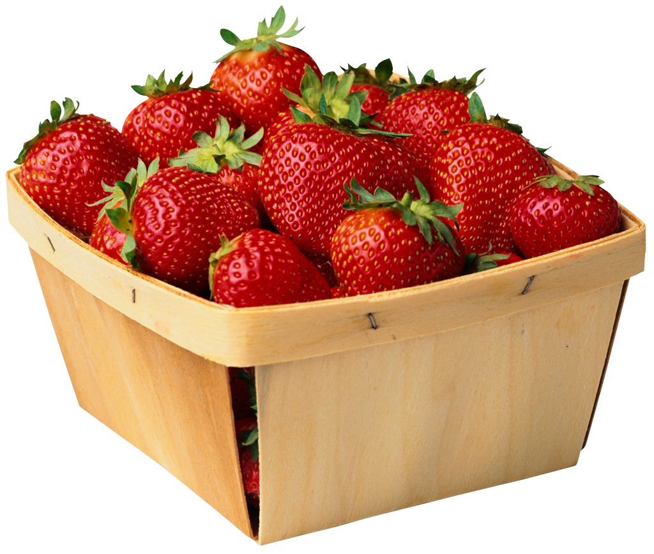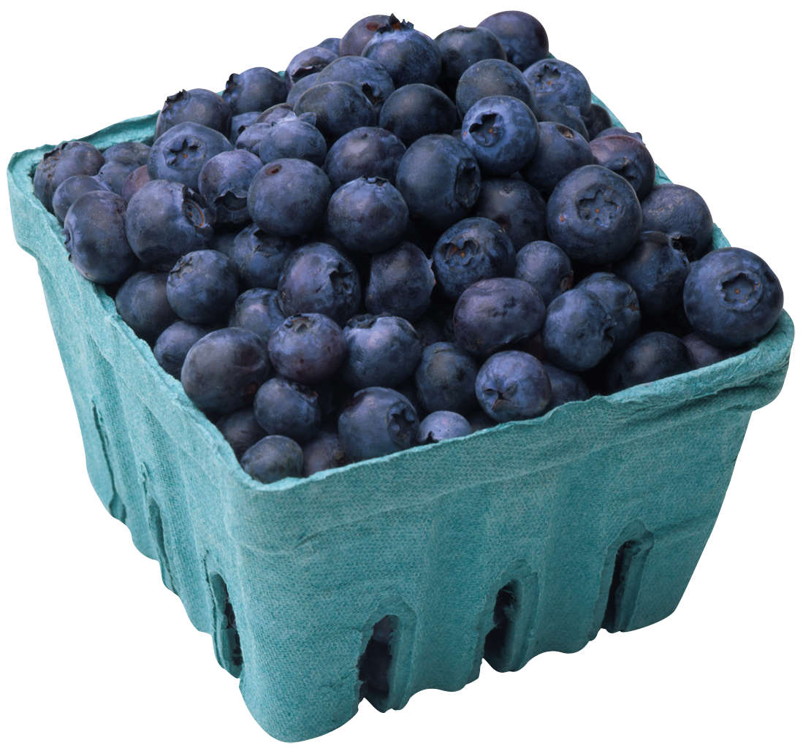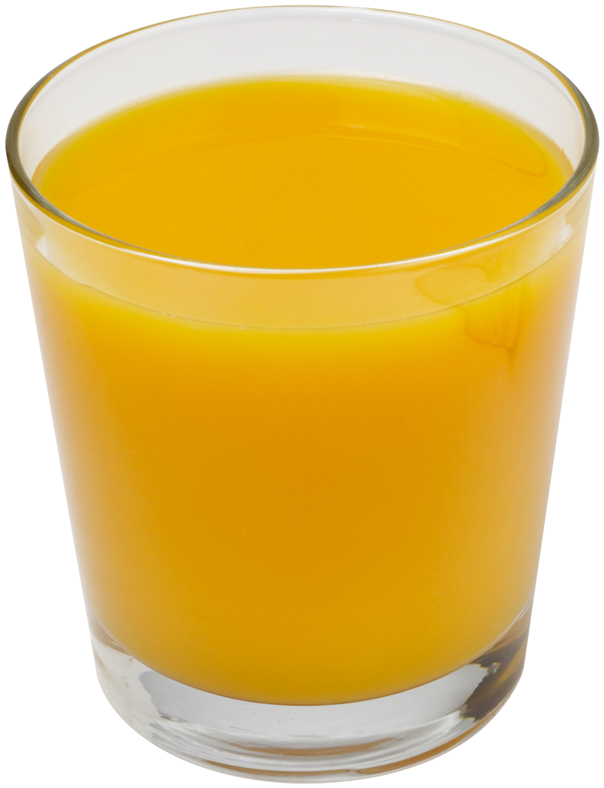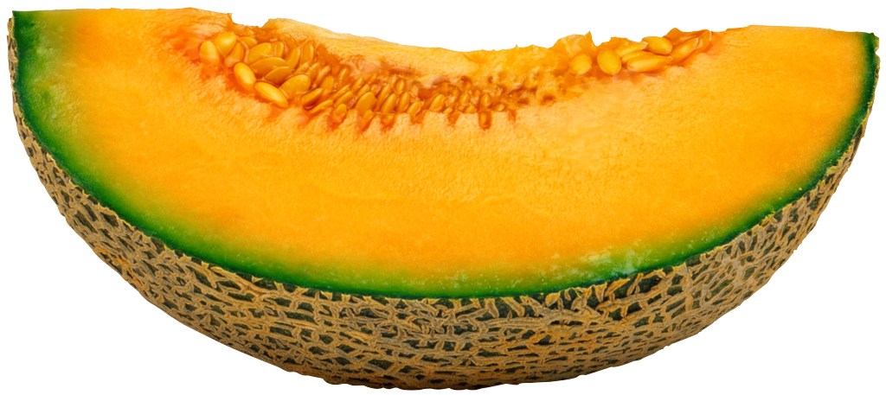

Yield: 2 servings

Frozen fruit is perfect for making smoothies because it eliminates the need for added ice to achieve a frosty, frothy texture.
After the banana and the frozen fruit, this recipe is infinitely flexible: use more or less milk, yogurt or orange juice; substitute soy or rice milk for the dairy products, or agave syrup or maple syrup for the honey.

2 cups any combination of frozen fruit
(blueberries, strawberries, raspberries, blackberries, mangos, peaches, etc.)
1 ripe banana, peeled and sliced
1 cup skim milk
(or non dairy: soy, almond, rice, etc.)
½ cup plain or vanilla yogurt
½ cup orange juice
2 to 3 tablespoons honey, to taste
(or agave syrup, maple syrup, etc.)

Put all ingredients in a blender and puree until smooth.

PER SERVING: Calories: 310 (12% from fat) Protein: 10 grams
Total Fat: 2 grams Cholesterol: 13 mg.
Carbohydrate: 63 grams Dietary Fiber: 4 grams Sodium: 95 mg.

BOOSTER: Flaxseed, Wheat germ, soy powder, etc. (See other side for information on Boosters.)

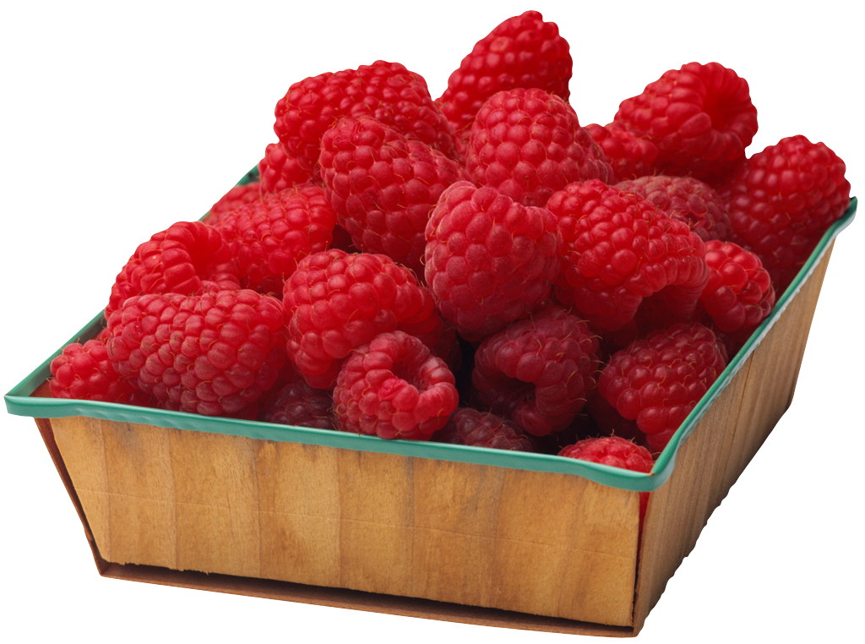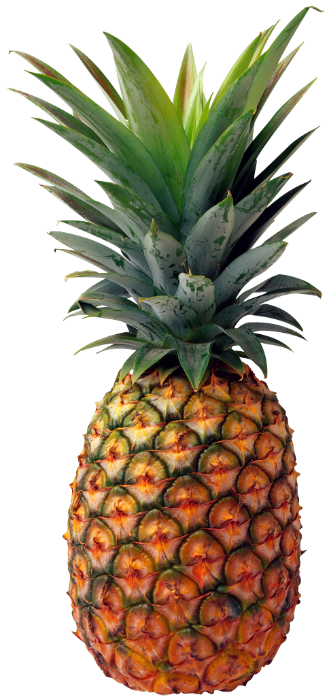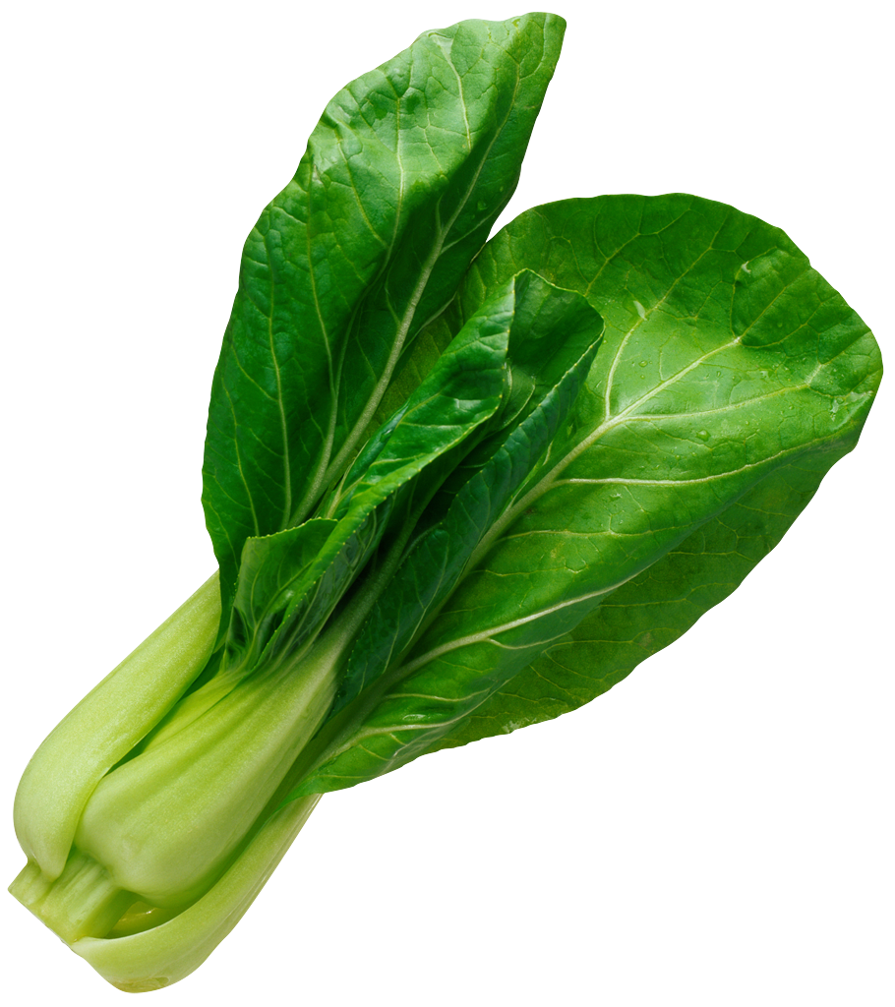

SMOOTHIE BOOSTERS:
Flaxseed: Rich in omega-3s, powerful fatty acids that strengthen immunity and promote heart and artery health; add 1-2 T. (1 T. = 35 calories, 3.5 g. fat, 2 g. carbs, 2 g. protein, 2 g. fiber)

Wheat germ: Excellent source of fiber, folate and the antioxidant vitamin E; top smoothie with 1-2 T. (1 T. = 25 calories, 0.5 g. fat, 3 g. carbs, 2 g. protein, 1 g. fiber)

Nonfat dry milk powder: Excellent source of fat-free, high-quality protein; add 2-4 tablespoons.
(1 T. = 15 calories, 2 g. carbs, 3 g. protein, 0 g. fiber)

Light or nonfat soy milk: Rich in iso-flavones that help build bone mass, reduce heat-disease risk, may impede malignant tumor growth and reduce hot flashes in menopausal women; replace milk or yogurt with soy milk. (1 c. = 110 calories, 2 g. fat, 20 g. carbs, 3 g. protein, 0 g. fiber)

Powdered acidophilus: Helps maintain the balance of intestinal “flora”, which promotes healthy bacterial that fight “bad” bacteria in the gut. The power form provides a much higher concentration of the desired organisms than yogurt or acidophilus milk. Always follow label recommendations.

FIBER RICH SMOOTHIE INGREDIENTS:
We could all use a little more fiber. Women should aim for 25 to 30 grams each day. Fiber keeps your tummy happy and prevents a bloated belly, reduces your risk of breast cancer and keeps you full longer, encouraging weight loss. Increase fiber by adding the following:

Avocado: A rich source of fiber; ¼ avocado = 80 calories and 3.4 grams of fiber.

Kale: A rich source of fiber; 1 cup of chopped kale = 34 calories and 1.3 grams of fiber.

Cannellini (white kidney) Beans: A rich source of fiber; ½ cup = 5 grams of fiber.

Almond Butter (unsalted): A rich source of fiber; 1 T. = 95 calories, 2 grams of fiber and 7 grams of protein.



