Name __________________________________________________________
Date _______________ Period _________ Culinary Arts – Vetter

FOOD PORTION DISTORTION QUIZ:
TEST YOUR DIET IQ

http://hp2010.nhlbihin.net/portion/portion.cgi?action=question&number

1. A bagel 20 years ago was 3 inches in diameter and had 140 calories.

Q: How many calories do you think are in today’s bagel? _________________________

2. A cheeseburger 20 years ago had 333 calories.

Q: How many calories do you think are in today’s cheese burger? _________________________

3. A portion of spaghetti and meatballs 20 years ago had 500 calories.

Q: How many calories are in today’s portion? _________________________

4. A 6.5-ounce portion of soda had 85 calories 20 years ago.

Q: How many calories do you think are in today’s portion? ________________________

5. 2.4 ounce of French fries of 20 years ago had 210 calories.

Q: How many calories do you think are in today’s portion? _________________________

6. A turkey sandwich had 320 calories 20 years ago.

Q: How many calories do you think are in today’s turkey sandwich? ________________________

http://hp2010.nhlbihin.net/portion/portion2.cgi?action=question&number=1

7. Coffee with milk and sugar 20 years ago was 8 ounces and 45 calories.

Q: How many calories are in today’s mocha coffee? _______________________

8. A muffin 20 years ago was 1.5 ounces and had 210 calories.

Q: How many calories do you think are in a muffin today? ______________________

9. Two slices of pepperoni pizza 20 years ago had 500 calories.

Q: How many calories do you think are in today’s large pizzas? ______________________

10. A chicken Caesar salad had 390 calories 20 years ago.

Q: How many calories are in today’s chicken Caesar salad? _____________________

11. A box of popcorn had 270 calories 20 years ago.

Q: How many calories do you think are in today’s tub of popcorn? _____________________

12. A slice of cheesecake was 260 calories 20 years ago.

Q: How many calories do you think are in today’s cheesecake? ____________________

13. A cookie was 55 calories 20 years ago.

Q: How many calories do you think are in today’s cookie? _____________________
14. Chicken stir-fry was 435 calories 20 years ago.

Q: How many calories do you think are in today’s chicken stir-fry? ______________________

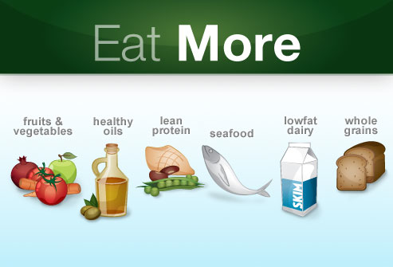

Name __________________________________________________________
Date _______________ Period _________ Culinary Arts – Vetter

FOOD PORTION DISTORTION QUIZ:
TEST YOUR DIET IQ

http://hp2010.nhlbihin.net/portion/portion.cgi?action=question&number

1. A bagel 20 years ago was 3 inches in diameter and had 140 calories.

Q: How many calories do you think are in today’s bagel? 350 (50 min.)

2. A cheeseburger 20 years ago had 333 calories.

Q: How many calories do you think are in today’s cheese burger? 590 (1hr. 30 min.)

3. A portion of spaghetti and meatballs 20 years ago had 500 calories.

Q: How many calories are in today’s portion? 1,025 (2 hr. 35 min.)

4. A 6.5-ounce portion of soda had 85 calories 20 years ago.

Q: How many calories do you think are in today’s portion? 250 (35 min.)

5. 2.4 ounce of French fries of 20 years ago had 210 calories.

Q: How many calories do you think are in today’s portion? 610 (1 hr. 10 min.)

6. A turkey sandwich had 320 calories 20 years ago.

Q: How many calories do you think are in today’s turkey sandwich? 820 (1 hr. 25 min.)

http://hp2010.nhlbihin.net/portion/portion2.cgi?action=question&number=1

7. Coffee with milk and sugar 20 years ago was 8 ounces and 45 calories.

Q: How many calories are in today’s mocha coffee? 350 (1 hr. 20 min.)
8. A muffin 20 years ago was 1.5 ounces and had 210 calories.

Q: How many calories do you think are in a muffin today? 500 (1 hr. 30 min.)

9. Two slices of pepperoni pizza 20 years ago had 500 calories.

Q: How many calories do you think are in today’s large pizzas? 850 (1 hr.)

10. A chicken Caesar salad had 390 calories 20 years ago.

Q: How many calories are in today’s chicken Caesar salad? 790 (1 hr. 20 min.)

11. A box of popcorn had 270 calories 20 years ago.

Q: How many calories do you think are in today’s tub of popcorn? 630 (1 hr. 15 min.)

12. A slice of cheesecake was 260 calories 20 years ago.

Q: How many calories do you think are in today’s cheesecake? 640 (55 min.)

13. A cookie was 55 calories 20 years ago.

Q: How many calories do you think are in today’s cookie? 275 (1 hr. 15 min.)

14. Chicken stir-fry was 435 calories 20 years ago.

Q: How many calories do you think are in today’s chicken stir-fry? 865 (1 hr. 5 min.)

