ROUX (pronounced “roo”) SLURRY (Using Cornstarch)

Made from equal parts of fat and flour. A cold liquid mixed with cornstarch.
Used for thickening sauces and soups. Used for thickening sauces, soups, stews, and desserts.
Added towards the start of cooking. Uncooked, added at the end of cooking.
Pre-cooking flour allows the starch granules to swell Used in recipes that call for a thickened clear sauce.
and absorb moisture, and thickens an opaque sauce Cornstarch can be mixed with water, wine or stock.
base without the flour clumping or forming lumps. Cornstarch has twice the thickening power as regular flour.
Browning the flour gives it a nutty, toasted flavor. If used with a citrus juice, the thickening power will be cut in half so use double the cornstarch.

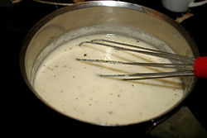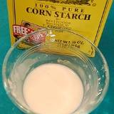

TEMPERING Adding beaten raw egg to hot mixture. (pudding)

