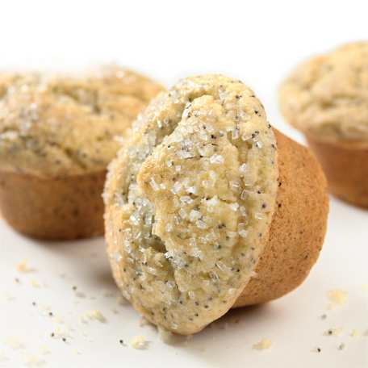
Sara’s Quick Muffins
Recipe Source: Chef Sara Moulton Yield: 1 dozen

Batter: Batter:
DRY ingredients WET ingredients
1 cup all purpose flour ½ cup melted butter or
½ cup whole-wheat flour or margarine
1 ½ teaspoon baking powder 1 cup sour cream
¼ teaspoon baking soda 1 egg
¼ teaspoon salt 1 teaspoon vanilla

EXTRAS: Circle choices
Sweet: 1/3 cup granular sugar or 1/3 cup brown sugar, ½ cup chocolate chips, ¼ -½ cup sweetened shredded coconut, 3 T. brown sugar/1 t. cinnamon, ¼ cup jam, etc.
Fruit: ½ - 1 cup Fresh/Frozen/Canned (mashed or chopped banana, chopped pineapple, chopped apple, blueberry, pumpkin, etc.)
Dried Fruit: ½ - 1 cup (raisins, currents, apricots, cranberries, cherries, etc.)
Protein: OMIT vanilla, 1/2 cup grated cheese, ¼ cup bacon bits, ½ cup chopped nuts, 1/3 cup peanut butter, 1/3 cup Chia seeds, etc.
Spice/Herb: 1 t. cinnamon, ½ t. nutmeg, 2 T. poppy seeds, 2 t. orange or lemon zest.

DIRECTIONS: (include cooking terms: stir, well, combine gently, moist, batter, grease)
- Preheat oven to 400.
- _______________________________________________________________________________________________________
- _______________________________________________________________________________________________________
- _______________________________________________________________________________________________________
- _______________________________________________________________________________________________________
- _______________________________________________________________________________________________________
- Bake 20 minutes, or until lightly browned and spring back when touched lightly in center. Remove the muffins from pans immediately, and place on the wire cooling rack.

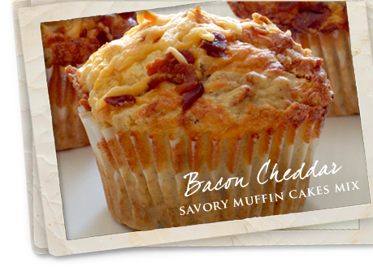

Sara’s Quick Muffins
Recipe Source: Chef Sara Moulton Yield: 1 dozen

Batter: Batter:
DRY ingredients WET ingredients
1 cup all purpose flour ½ cup melted butter or
½ cup whole-wheat flour or margarine
1 ½ teaspoon baking powder 1 cup sour cream
¼ teaspoon baking soda 1 egg
¼ teaspoon salt 1 teaspoon vanilla

EXTRAS: Circle choices
Sweet: 1/3 cup granular sugar or 1/3 cup brown sugar, ½ cup chocolate chips, ¼ -½ cup sweetened shredded coconut, 3 T. brown sugar/1 t. cinnamon, ¼ cup jam, etc.
Fruit: ½ - 1 cup Fresh/Frozen/Canned (mashed or chopped banana, chopped pineapple, chopped apple, blueberry, pumpkin, etc.)
Dried Fruit: ½ - 1 cup (raisins, currents, apricots, cranberries, cherries, etc.)
Protein: OMIT vanilla, 1/2 cup grated cheese, ¼ cup bacon bits, ½ cup chopped nuts, 1/3 cup peanut butter, etc.
Spice/Herb: 1 t. cinnamon, ½ t. nutmeg, 2 T. poppy seeds, 2 t. orange or lemon zest

DIRECTIONS:(include cooking terms: stir, well, combine gently, moist, batter, grease)
- Preheat oven to 400. (convection convert)
- strainer. Stir dry ingredients till all pass through strainer or sift.
- In Set strainer in a medium sized mixing bowl. Measure and place dry ingredients in small mixing bowl measure wet ingredients. Blend with a whisk.
- Pour wet into well of dry. Stir till dry ingredients are moist. May be lumpy.
- Measure 1-cup total combined special ingredients and gently fold into batter.
- Spoon batter into 12 lined or greased muffin tins. Fill 2/3 full.
- Bake 20 minutes, or until lightly browned and spring back when touched lightly in center. Remove the muffins from pans immediately, and place on the wire cooling rack.

