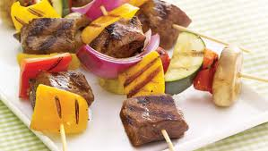

Steak & Pepper Kebabs Yield: 4-5

DAY 1:
_______ 3 tablespoons sesame oil
_______ 1 tablespoon lime juice
_______ 2 tablespoons soy sauce
_______ 1 (1-inch) piece ginger, peeled and grated or ½ t. powdered
_______ 2 cloves garlic, minced (2 teaspoons)
_______ 1 teaspoon sugar
_______ 1/8 teaspoon salt
_______ 1 pound boneless beef sirloin, cut into 1½ -inch cubes
- In a small bowl, combine oil, lime juice, soy sauce, ginger, garlic, sugar, and salt.
- Place beef in a re-sealable 1-gallon freezer bag. Add marinade and shake to coat. Refrigerate for 1 hour.
DAY 2:
_______ 1 each red, yellow, and orange bell peppers, cut into 1-inch pieces
_______ 2 zucchini’s, cut into 1-inch pieces
_______ 1/3 fresh pinapple, cut into 1-inch squares
_______ 1 small onion, cut into 1-inch pieces
- Raise oven rack to 3 inches from element.
- Soak 8 wooden skewers in water for at least 15 minutes.
- Remove beef cubes from bag; discard marinate. Thread on skewers, alternating with bell peppers.
- Broil (low) kebabs on foil lined broiling pan for 6 – 8 minutes, turning once, until beef reaches desired doneness and vegetables soften and brown.

PER SERVING: calories: 230; protein: 26 grams; total fat: 11 grams; cholesterol: 60 mg; sodium: 170 mg; carbohydrate: 6 grams; dietary fiber: 2 grams.

Recipe from “dashrecipes.com”

