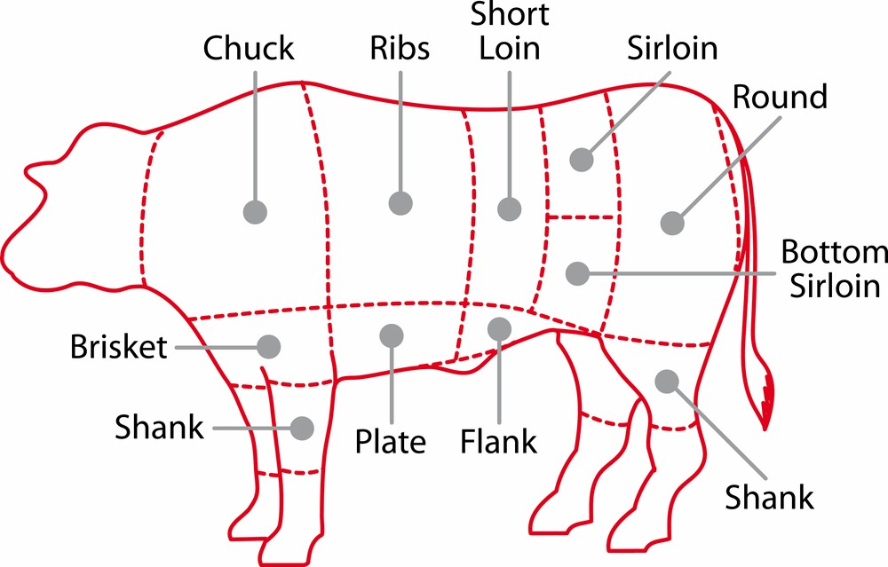
Name: _________________________________________________
Date: ___________________ Period: _____
Culinary Arts

Ch. 19 MEAT COOKERY Study Guide
Refer to pages 320-333 in the “Guide to Good Food” textbook.

Nutrition Values

- How many ounces of protein do most teens need each day? _____________ oz.
- Meats contain proteins essential for ________________________________________________________________.
- Meats are also good sources of ________________________, _____________________, ______________________.
- Ground meats are generally higher in fat. When selecting ground meat, choose at least _________% lean.
- Choosing lean cuts such as _____________________ & ______________________ sections of beef and the ______________________________ & _____________________________ sections of pork.
- Use cooking methods such as _____________________________ & __________________________ and nonstick pans when _______________________ & __________________________ to eliminate the need for added fat during cooking. Trim the fat from the surface of chilled meat ______________________ & ______________________.
- The carcass of meat is first cut into smaller pieces called _____________________________ cuts and then cut into even smaller pieces called _________________________ cuts which are sold at the grocery store.
- The difference between “Ground Beef” and “Hamburger” is ground beef contains only _____________ originally attached to the meat before grinding.

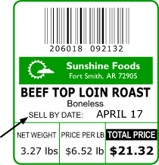
Reading a Meat Label

- What is the wholesale cut from which this piece
of meat comes from? _______________________
- What is the name of the retail cut? _______________________
- How much does this piece of meat weigh? _____________ lbs.
- What is the unit price of this meat? $ _________________ lb.
- How much would you have to pay for this package of
meat? $ _________________

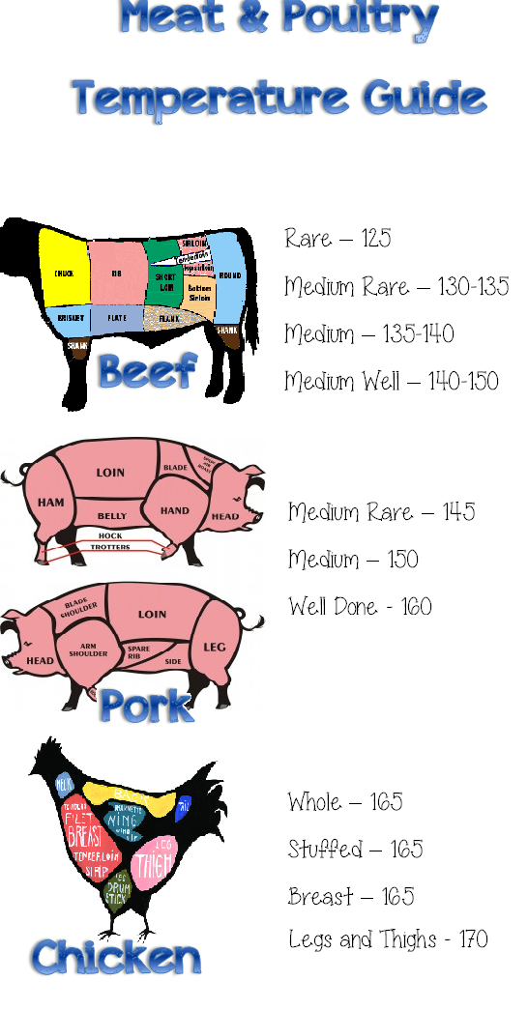
Meat Preparation & Cooking
- The suggested time frames during which different types of
meats can be refrigerated is between ________ - ________ days.
- Meat consists of connective tissues called
____________________________ and ____________________________.
- Describe the tenderizing method to break down connective tissue:

- Pounding/Grinding
_________________________________________________________________________
- Slicing/Cubing
__________________________________________________________________________
- Commercial Meat Tenderizer
__________________________________________________________________________
- Marinade
__________________________________________________________________________
- The safety guidelines regarding the use of a marinade with
raw meat, suggest you keep marinade _____________________, discard
after use, or boil for 1 minute before using on cooked meat.
Meat 101

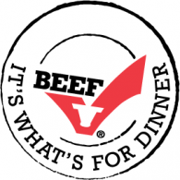
- _______ Meat obtained from mature cattle over 12 months of age. A. meat
- _______ The meat of sheep less than one year old. B. pork
- _______ The edible portion of mammals. C. veal
- _______ The meat of swine. D. beef
- _____ The meat of cattle less than three months of age. E. lamb
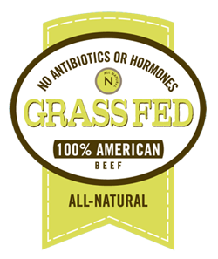
- _____ Edible parts of animals other than muscle, such as liver & heart. A. Prime
- _____ Flecks of fat found throughout the lean muscles of meat. B. Choice
- _____ More internal fat, and is more tender and juicier than select. C. Marbling
- _____ Less marbling, fairly tender, but may lack juiciness and flavor. D. Variety Meats
- _____ Abundant flecks of fat within the lean meat and sold in restaurants. E. Select

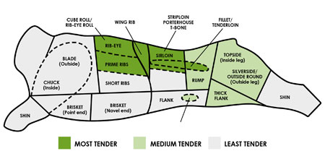
- _____ Doesn’t allow animal to
be given grow hormones
& antibiotics. A. Grass Fed
- _____ Cattle confined in feed lots
and eat mostly grain. B. Grain Fed
- _____ Cattle spend a majority of
their lives eating grass on
pastures. C. Organic
- _____ Broil, Grill, Roast D. Moist
- _____ Braise, Stew E. Dry
