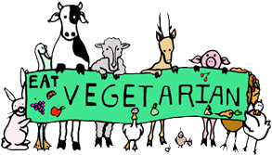
Name _________________________________
Date ___________________ Period ________

Veganism is a type of vegetarian diet that excludes meat, eggs, diary products and all other animal-derived ingredients.
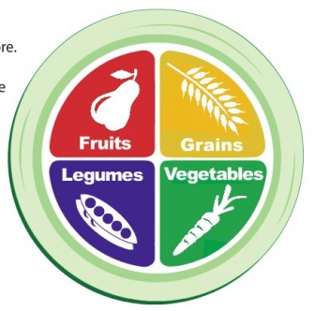
Ovo vegetarianism includes eggs but not dairy products.

Lacto vegetarianism includes dairy products but not eggs.

Ovo-lacto vegetarianism includes animal/dairy products
such as eggs, milk, and honey.

Directions: Analyze the meals listed below and identify
the type of vegetarian eating style for which that meal
would be typical. Write the type of style on the line
provided.

__________________________ 1. For dinner, Donovan made a casserole that contained broccoli, cauliflower, carrots, rice, and tofu.
__________________________ 2. Kira is planning dinner for her friends. She decides on a menu of egg drop soup, fried rice, and vegetables, with fruit salad for dessert.
__________________________ 3. For lunch, Reagan ate an egg salad sandwich, a glass of milk, and a handful of nuts.
__________________________ 4. When the basketball team went for pizza after practice, Noah ordered his with extra cheese, onions, and green peppers.
__________________________ 5. Lakisha’s favorite breakfast is scrambled eggs topped with salsa and melted cheddar cheese.
__________________________ 6. For dessert, Jorge often has a dish of soy yogurt with fruit topping.
__________________________ 7. Elisa ordered a soy burger, cheese fries, and a milkshake for her lunch.
__________________________ 8. When he got home from school, Spencer snacked on a deviled egg, some dried apricots, and a glass of iced tea.
__________________________ 9. For Sunday brunch, Zoe served her family a spinach and cheese quiche, wheat toast, and orange juice.
__________________________ 10. A bowl of whole grain cereal with soymilk and fresh strawberries is Manuel’s favorite breakfast.

Directions: Vegetarians can get enough of each nutrient by choosing foods carefully. Complete the Chart below by listing nutrients that will help vegetarians meet their needs for the foods indicated. (Nutrients Needed: Calcium, Iodine, Iron, Protein, Vitamin D, Vitamin B12, Zinc)
Nutrient Needed | Foods
1. | Iodized Salt
2. | Eggs, dairy foods, a variety of plant based foods
3. | Broccoli, calcium, fortified soy milk, calcium fortified orange juice, dry beans, seeds
4. | Fortified milk, breakfast cereal, soy drinks
5. | Fortified cereals or soy products, eggs, dairy products
6. | Dark leafy vegetables, dry beans, seeds, enriched or fortified whole grain breads & cereals
7. | Whole grain breads & cereals, dry beans, nuts, seeds, wheat germ & tofu

8. What are 5 reasons a person might have for choosing to be a vegetarian?
_____________________, _____________________, ______________________,
_____________________, _____________________



