Name _____________________________________________________ Kitchen _________ Date ______________
Tillamook Cheese Factory Culinary Arts

The Tillamook Story (5:12) http://www.youtube.com/watch?v=l4ZWzr2fD7k

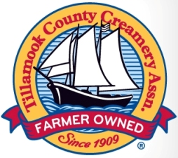
Tillamook was destined to become a dairy property because of the ideal __________________________,

___________________________________, __________________________________ and __________________________________.

Tillamook County Farmers Co-Op = farmer owned, farmer produced

1 million ___________________________ per year

Tillamook employees have ______________________ and put quality into their product.

How to Make Tillamook Cheese (3:54) http://www.youtube.com/watch?v=PFjOJpoenlw
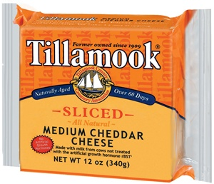
Farm milk is made into Tillamook cheese in less than _____________ hours.

Peter McIntosh brought the cheddar cheese _______________________ to Tillamook in _________________.

Dale Baumgartner – Head _________________________________ for over 17 years.

100 pounds of ______________________________ makes 10 pounds of _______________________________________

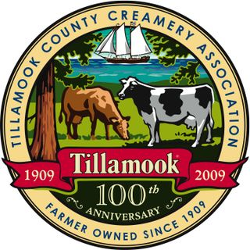
Tillamook makes ___________________ pounds of cheese per day, __________ million pounds each year.
Step 1: _______________________________________________________________________________________________________
Step 2: _______________________________________________________________________________________________________
Step 3: _______________________________________________________________________________________________________
Step 4: _______________________________________________________________________________________________________
Step 5: _______________________________________________________________________________________________________
Step 6: ______________________________________ Storage facility is exactly _____________ F.
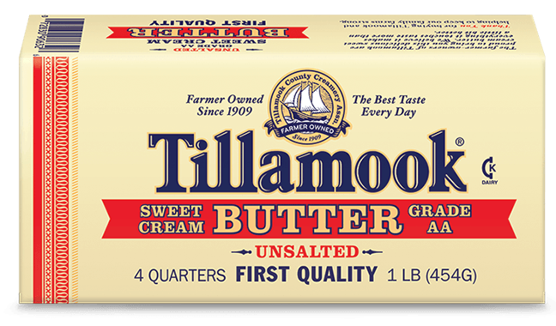
Step 7: ______________________ According to Jill, the manager of product quality at Tillamook, tests are conducted on every _________________________ of cheese produced.
Step 8: ______________________________________________________________________________________________________

How To Make Tillamook Ice Cream (3:04) http://www.youtube.com/watch?v=mKE41haM9Kg
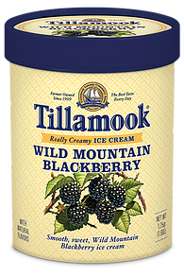
Ingredients: fresh milk, cream and nonfat dried milk. ___________% butterfat content.

Overrun is the amount of air added to ice cream. Low overrun + less air = more __________________.

Sensory sampling takes place every __________________________ minutes.

Inclusion means stuff Tillamook puts into ice cream. Inclusions include: _____________________________

________________________________________________________________________________________________________________

________________________________________________________________________________________________________________

